4 x 1000L brewing equipment set for sale. The set has been used 3 years, it is complete and operational, available for viewing.
Brewhouse Unit

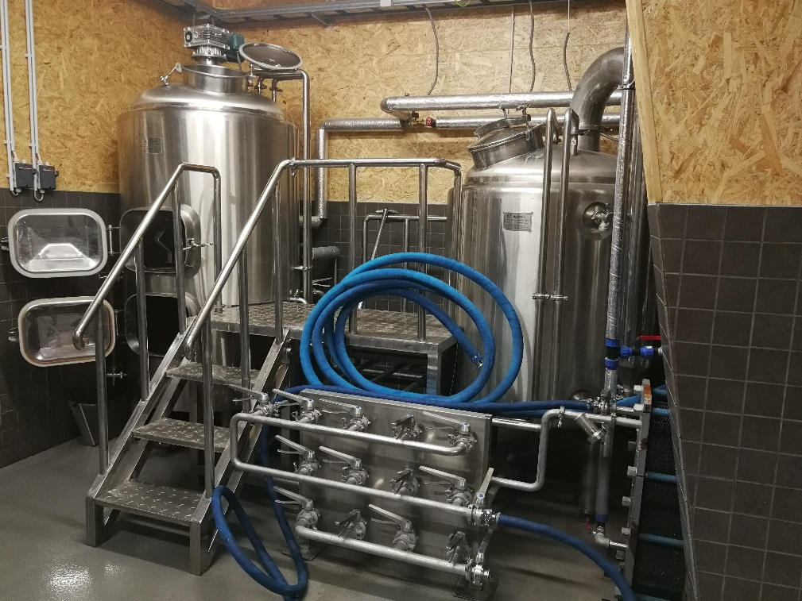
- Mash/Lauter  Tank Capacity: 500L (+25% Headspace minimum)  Dimension: Φ1060mmx2800mm  Interior Shell: SUS304 full welded; TH=3mm  Exterior Shell: SUS304 full welded; TH=2mm  100% TIG welding with pure argon gas shield  Interior Finish: Overall polishing to 0.4~0.6 μm without dead corner  Insulation: Rock wool; TH=80mm  Heating: Steam  Dished top and sloped bottom  Stainless steel top mounted manway  Side mounted grain outdoor with grain chute  360° coverage CIP spraying ball  Grain rake with VFD controlled motor and turbine reducer  Easy clean and detachable sparging spray ring  Inline wort lauter sight glass  Laser cutting V-wire False Bottom/Filter  Tangential whirlpool inlet  4pcs completely SUS304 heavy duty legs with leveling pad  Thermowell with high accuracy temperature sensor | - Kettle  Tank Capacity: 500L (+30% Headspace minimum)  Dimension: Φ1060mmx2500mm  Interior Shell: SUS304 full welded; TH=3mm  Exterior Shell: SUS304 full welded; TH=2mm  100% TIG welding with pure argon gas shield  Interior Finish: Overall polishing to 0.4~0.6 μm without dead corner  Insulation: Rock wool; TH=80mm  Heating: Steam  Steam Jacket: Dimple plate on bottom and side  Dished top and sloped bottom  Stainless steel top mounted manway  360° coverage CIP spraying ball  Sanitary leveling sight glass  Steam vent by steam condenser with spray nozzles  Thermowell with high accuracy temperature sensor  4pcs completely SUS304 heavy duty legs with leveling pad
- Transfer  1pcs Centrifugal Pump: 3M3/Hr; Sanitary SUS304  Centralized hard-piped manifold for liquid flow controlling  Hard piping: Sanitary SUS304; Self-draining  Inline sight glass for checking wort clarity and color  Hose: Reinforced food grade; 150℃ resistance; odorless, tasteless  Complete valves, fittings and all parts  Every weld to a smooth sanitary finish  Stainless steel multiply-position lever handle  butterfly valve | - Work platform  Stainless-steel setup  Non slip metal floor  Integrated stairs  Solid and ground handrail  Every weld to a smooth sanitary finish
- Heat exchanger

Function: Wort cooling
Two stages for glycol water and cold water
Completely 304 SS Corrugated plates
Full detachable for regular thorough cleaning
Thermometer for wort outlet temperature controlling
Effective Cooling Area: 6M2
Design/Test Pressure: 10bar/13bar
Working Temperature: <150℃
Sanitary wort aeration mounted with stone
City water, glycol water, wort inlet and outlet
Dimension: 380x225x530mm

Steam Generator

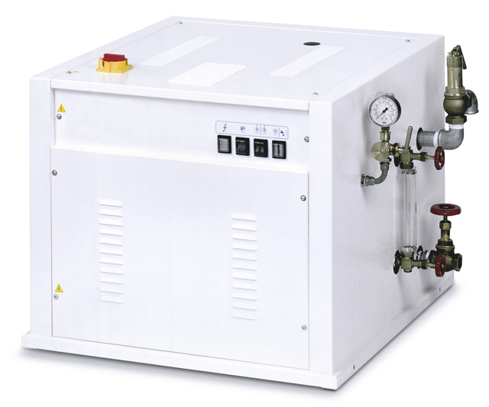
Electric and automatic steam generator MAXI 60
Available steam production 30Kw
Water feed can be connected directly to the water mains
Steam output 40 kg/h
Overall dimensions 900x900x780 mm
Set of steam valves included

1000L Fermentation Tank/Unitank; 4 pcs (4 x 1000L)

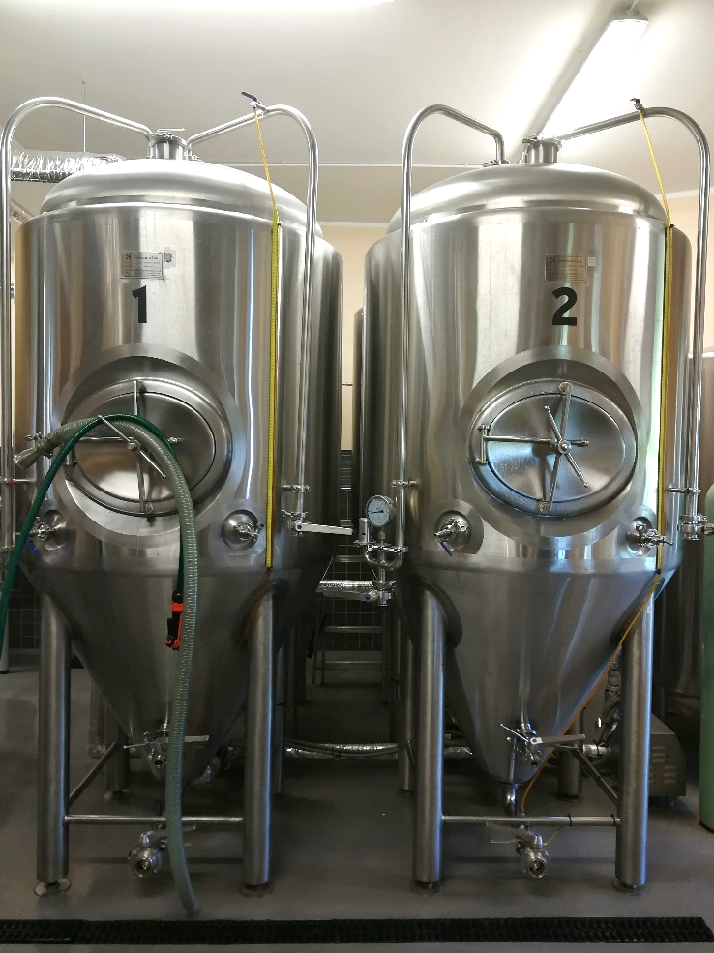
Function: Wort Fermentation or maturation
Tank Capacity: 1000L (+25% Headspace minimum)
Dimension: Φ1210mmx2550mm
Interior Shell: SUS304 full welded; TH=3mm
Exterior Shell: SUS304 full welded; TH=2mm
100% TIG welding with pure argon gas shield
Interior Finish: Overall polishing to 0.4~0.6 μm without dead corner
Insulation: Polyurethane; TH=80mm
Glycol Jacket: Dimpled plate on cone and side
Dished head and 60-degree cone bottom
Sanitary side mounted manway
CIP arm with 360° coverage CIP spraying ball
CO2 blow-off arm with butterfly valve
Full sanitary sampling valve
Mechanical relief valve 2 bar on CIP arm
Shockproof pressure gauge on CIP arm
Rotating racking arm and port on cone with butterfly valve
Tri clamp discharge arm with butterfly valve
Thermowell with high accuracy temperature sensor
4pcs completely SUS304 heavy duty legs with leveling pad and legs support
Complete valves, fittings and all parts
Dry hopping port with solid end cap
Level tube
Carbonation port and stone

Glycol Cooling Unit

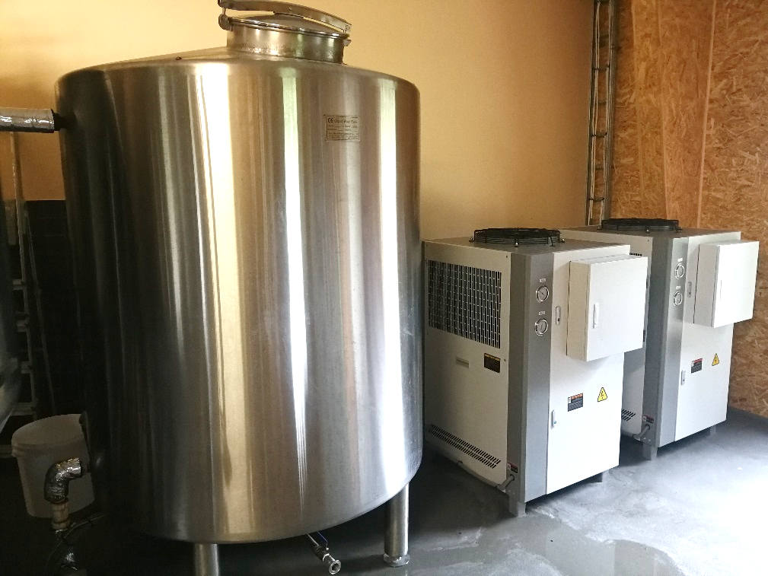
- Glycol Water Tank  Function: Glycol water supply for wort cooling and fermentation cooling  Tank Capacity: 1500L (+10% Headspace min)  Dimension: Φ1360×1900mm  Interior Shell: SUS304 full welded; TH=3mm  Exterior Shell: SUS304 full welded; TH=2mm  100% TIG welding with pure argon gas shield  Interior Finish: Overall polishing to 0.4~0.6 μm without dead corner  Insulation: Polyurethane; TH=80mm  Insulated flat lid cover on top and sloped bottom  Thermowell with high accuracy temperature sensor  Discharge arm with butterfly valve  4pcs completely SUS304 heavy duty legs with leveling pad  Glycol water inlet and outlet  Includes 1500L glycol water mix | - Chiller  Function: Glycol water chilling  2sets  Cooling Capacity: 6600Kcal/3HP  Installed Power: 3.3kw  Refrigerant: Freon R404A, R410A  Efficient fans  Stainless steel pump for glycol water recycle  Protector for pressure, overload, anti-freeze, delay, overtemperature, flow  Size: 850x720x1325mm
- Glycol Water Transfer

Function: Glycol water circulation
1pcs Centrifugal Pump: 3M3/Hr; Sanitary SUS304
Standard PPR glycol piping loops
Matched connection piping fittings
Insulation foam for supply and return loops
Solenoid valves for glycol inlet to tanks

Controlling Unit

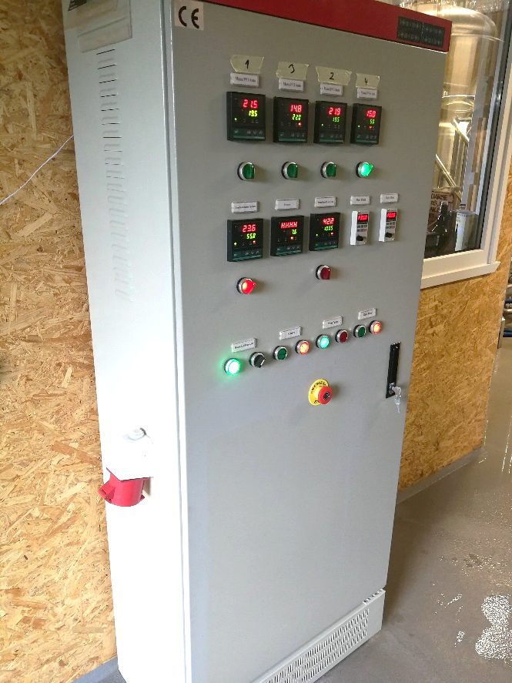
Function: Brewery controlling
Cabinet Material: Anti-power Plastic painting
Instrument panel
Assembling Style: Floor Type/Wall hanging
Electrical Parts: CE certificated
Mashing Pump on/off included VFD
Rake or Agitator motor on/off included VFD
Temperature display and Auto/Manu heating Control for brewhouse tanks
Auto/Manu Glycol Water Pump control
Auto/Manu Chiller control
Temperature display and Auto/Manu Control for FVs
Temperature display and Control for GWT and CLT

CIP Cart Unit

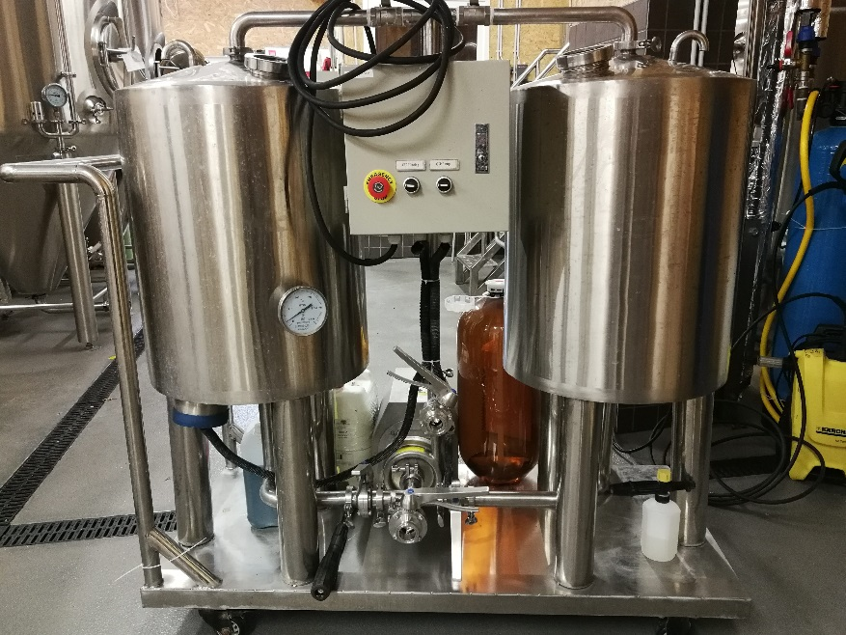
- Caustic Tank  Function: Caustic liquid heating and mixing  Tank Capacity: 100L  Dimension: Φ500×1150mm  Shell: SUS304 full welded; TH=2mm  Interior Finish Polish: 0.4~0.6 μm  Caustic tank with 4kw electric heating element  Cone top and bottom  Top glass porthole  Valves and fittings included | - Sterilization Tank  Function: Sterilization liquid mixing  Tank Capacity: 100L  Dimension: Φ500×1150mm  Shell: SUS304 full welded; TH=2mm  Interior Finish Polish: 0.4~0.6 μm  Cone top and bottom  Top glass porthole  Valves and fittings included
- Liquid Transfer

Portable cart with wheels and handle
1pcs Fixed Pump: 3M3/Hr; 0.75kw
Electromagnetic starter for pump on/off
Hose: Reinforced food grade; 150℃ resistance; Odorless, tasteless
Hard piping: Sanitary SUS304; Self-draining
Every weld to a smooth sanitary finish
Complete circulation piping and fitting

