Spett.le

“ Cider Mill ”
Parma, 17/06/2016
Ref. : Sig. Davide Tosi

OFFERTA

- N ° 01 PORTIONING from ROCK18 counter.
With mold for semi-hard cheese, you can cut into cubes of varying weights forms;
is constructed entirely of stainless steel, the mold is made of stainless steel cutlery from 420

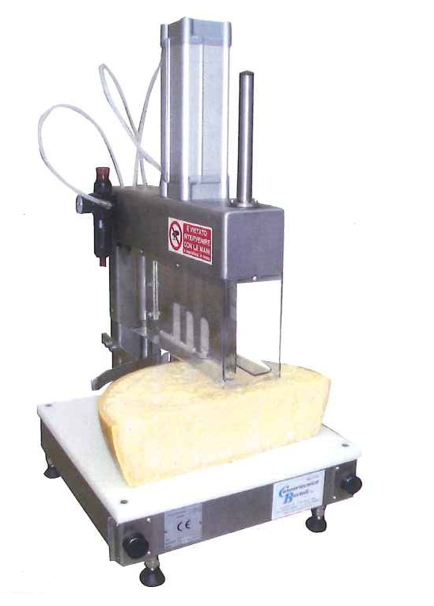…………………………………………………..…………………..……..€ 4.100,00

• N ° 01 SIZE CRUST AND SEGMENTS counter
With polyethylene food plan to get pieces and weight cubes and dimensions
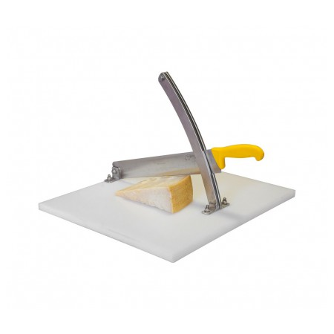.…………………….................... ………………€ 260,00

- PREZZO : IVA esclusa
- CONSEGNA : da definire
- PAGAMENTO : da definire
- TRASPORTO &
INSTALLAZIONE: : da definire

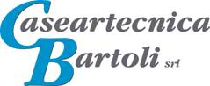
Davide Tosi

